Siqi Wu | ECE 693 Computer Vision | December 9, 2015

Segmenting Foods

semester Project

# I. Introduction

This project is an image segmentation tool that uses active contour to segment food images. This tool has three different modes including rubber band, balloon, and manual mode. The manual mode allows user to manually drag a point on the existing contour to another position. After a point is drag, it starts another active contour process.

# II. Details of Implementation

**1. Windows chosen in calculating energies of the three modes**

1). Rubber Band: 11

2). Balloon: 5

3). Manual: 5

**2. Energies chosen in three modes**

1). Rubber Band

Energy = 5 * inter1 + 1 * inter2 + 1* colordif - 2 * exter

Where inter1 is the distance of each point to the next point in the contour. Inter2 is the difference between the average distance and the distance to the next point. exter is the gradient of the image. colordif is the difference of each point to the center of the initial contour.

2). Balloon

Energy = 1 * inter1 - 4 * inter2 - colordif + 0.5 * exter

Where inter 1 is the distance from the center of the circle (initial contour of balloon algorithm). Inter2 is the difference between the average distance and the distance to the next point. colordif is the difference of each point to the center of the initial contour. exter is the gradient of the image.

3). Manual

Energy = 1 * inter1 - 2 * inter2 – 0.5 * colordif + (1/3) * exter

Where inter1 is the distance of each point to the next point in the contour. Inter2 is the difference between the average distance and the distance to the next point. Here the next point of the contour is redefined. When a point is dragged, this point is marked as locked. The points in the existing contour are separated to two half using the locked point as the middle point. For each half of the contour, the next point is defined as the point towards the locked point, i.e. the locked point would be the end of both the two half of the contour. And the opposite point of the locked point is the initial point of the two half. colordif is the difference of each point to the center of the initial contour. exter is the gradient of the image.

**3. Windows chosen in calculating color of the center**

In all three modes, a window of size 9 is chosen to calculate the color of the center of contour. The average values of R, G, B channels are considered as the color of the center.

**4. Windows chosen in smoothing the image**

In all three modes, a window of size 7 is chosen to smooth the image in order to better use the gradient energy.

# III. Result of Experiments

For the five given images, the best experiment results are shown below.

1) Bacon-eggs- toast

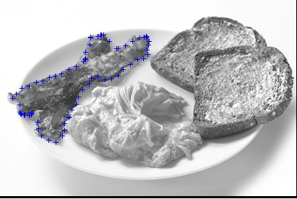

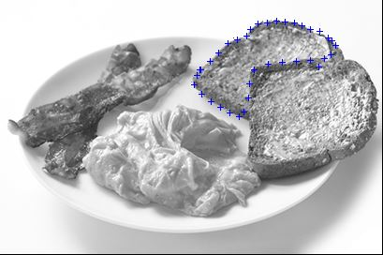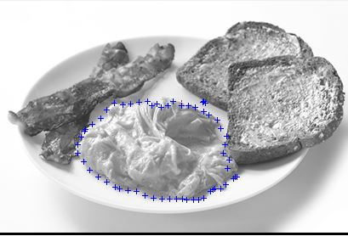

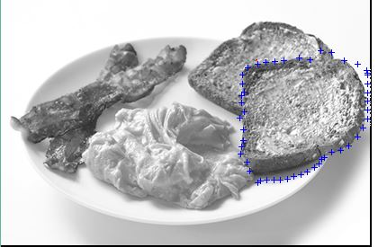

For balloon algorithm

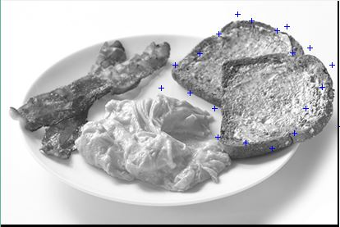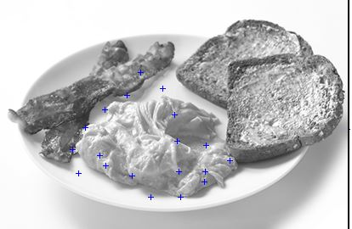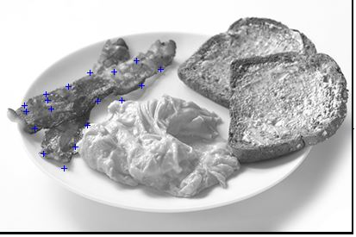

2) Eggs-pancakes-milk

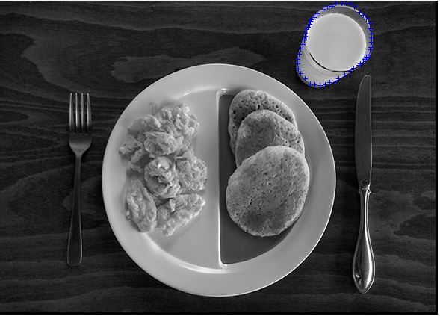

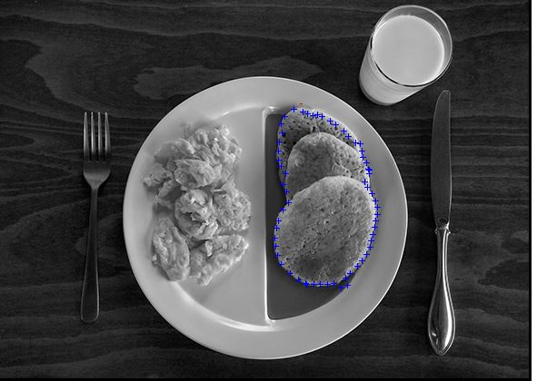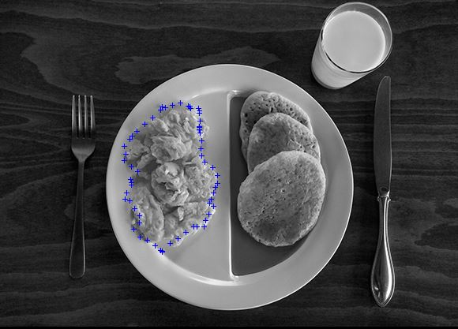

For balloon model

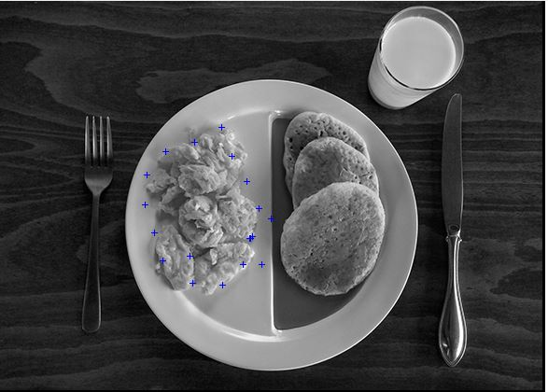

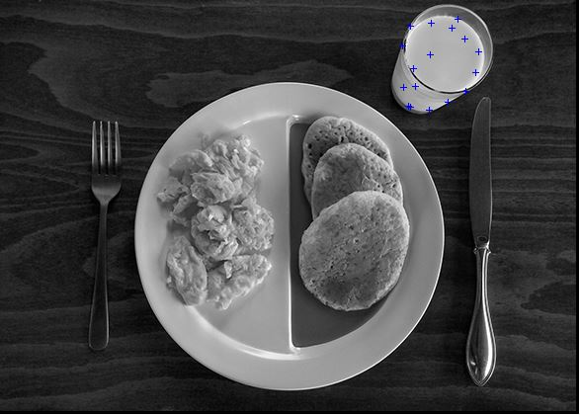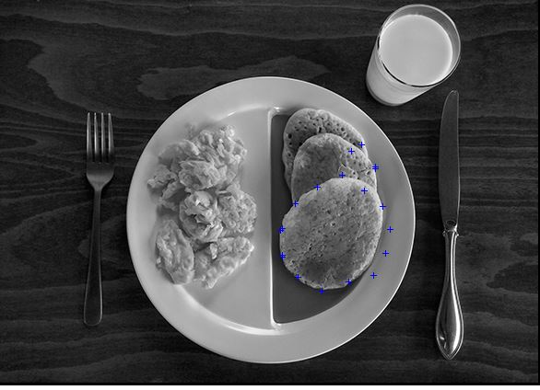

3) fish-lemon-rice-greens

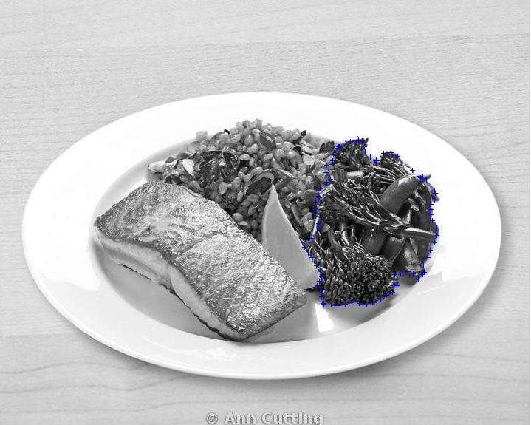

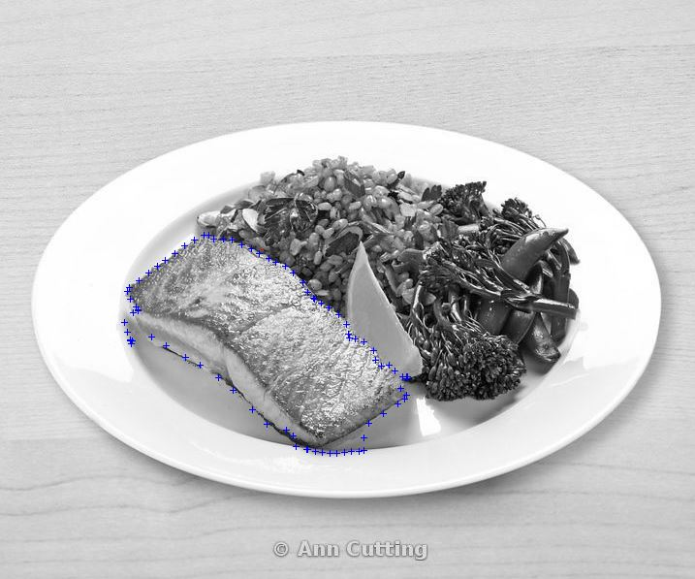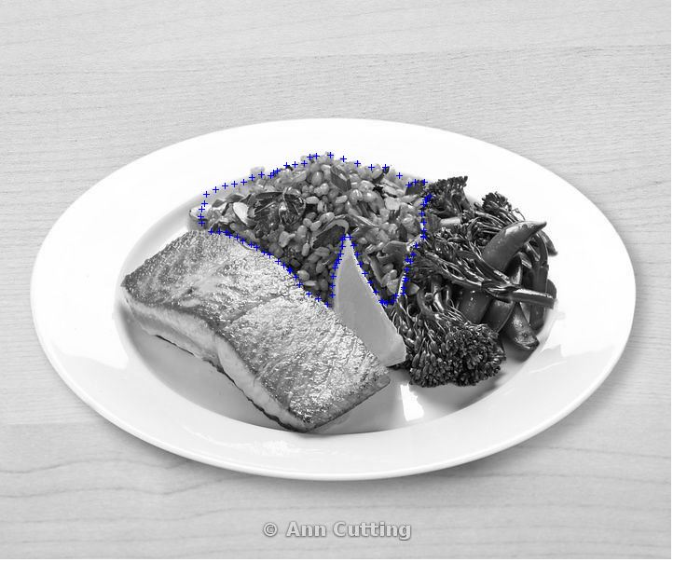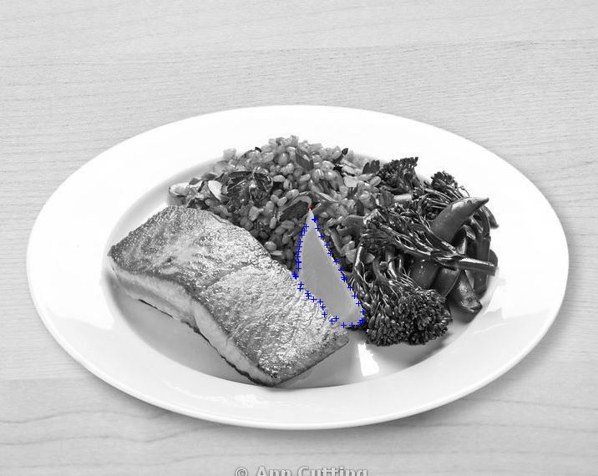

For balloon model

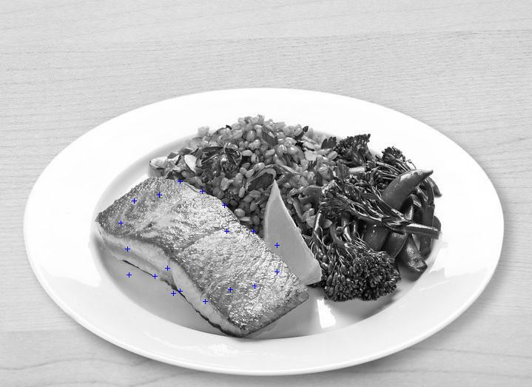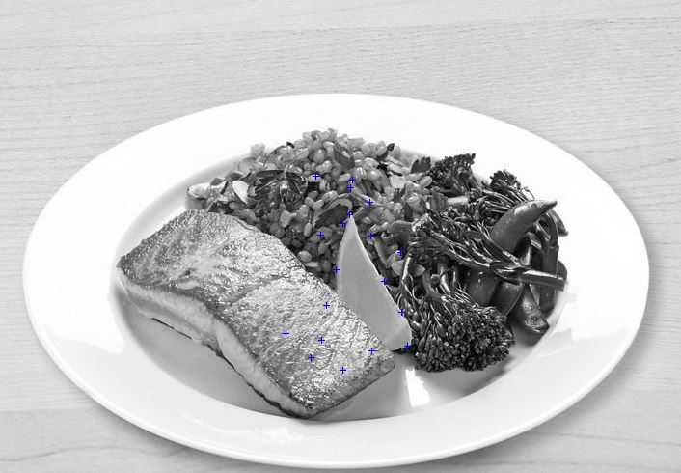

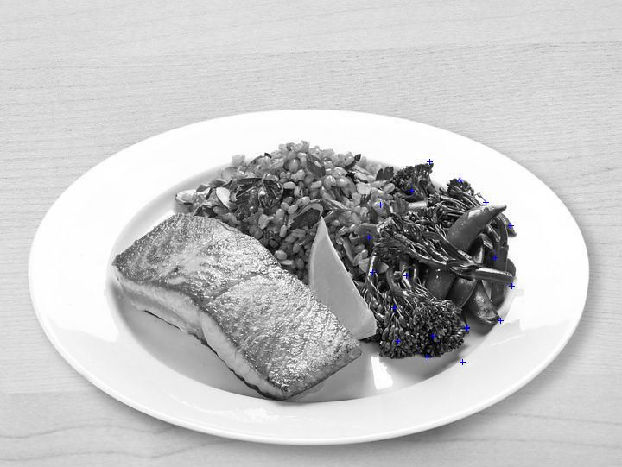



4) hushpuppies-biscuits

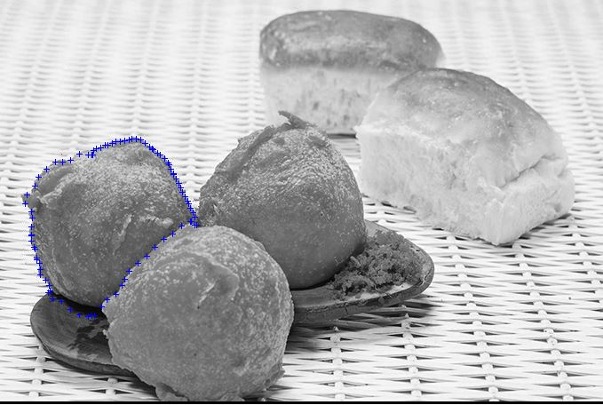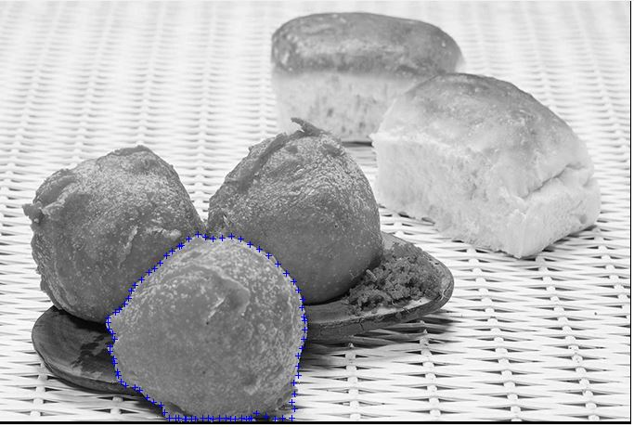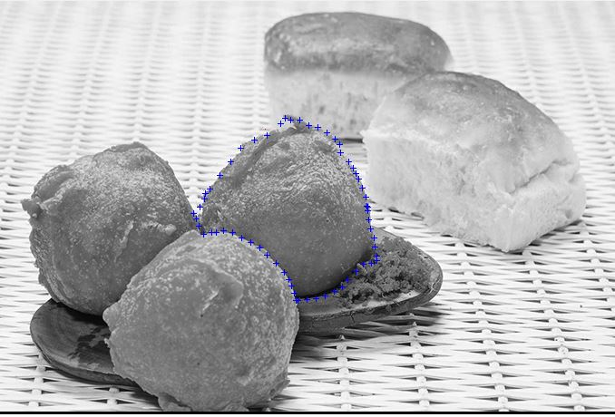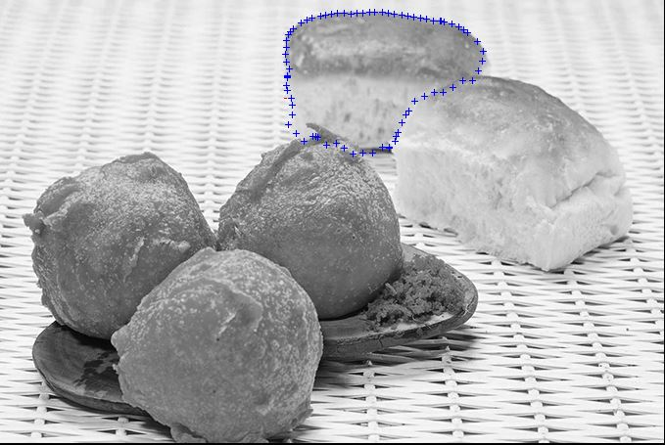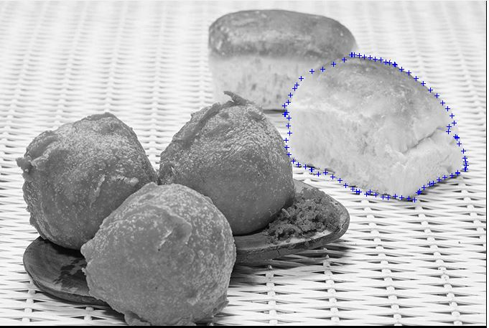

For balloon model

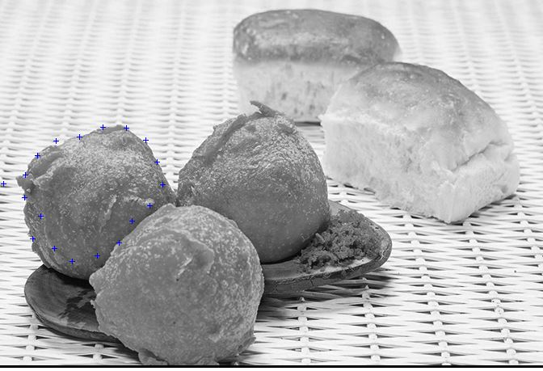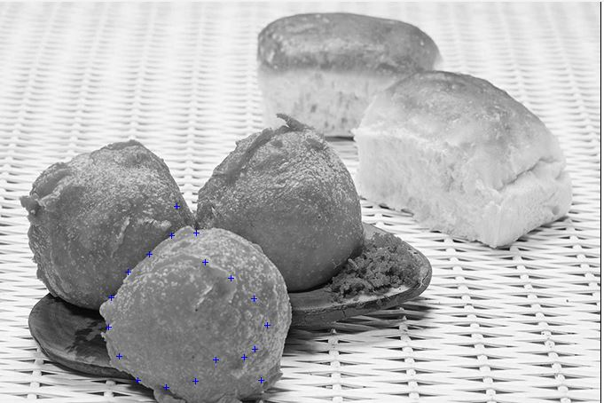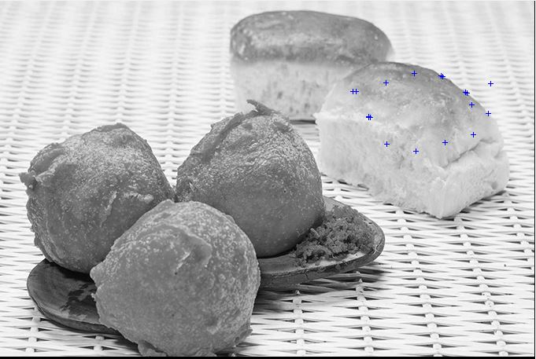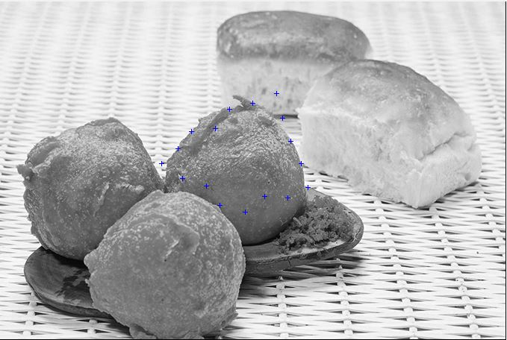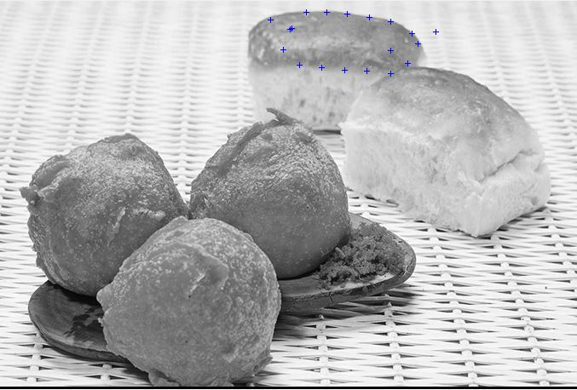

5) macaroni-kale

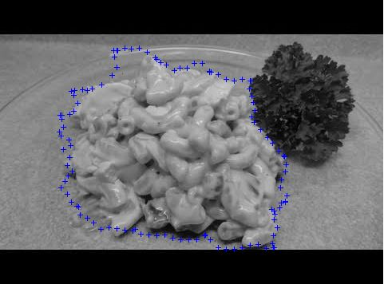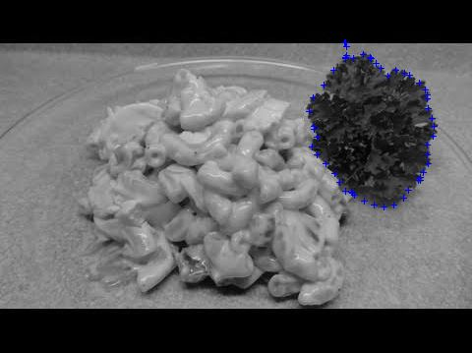

For balloon model

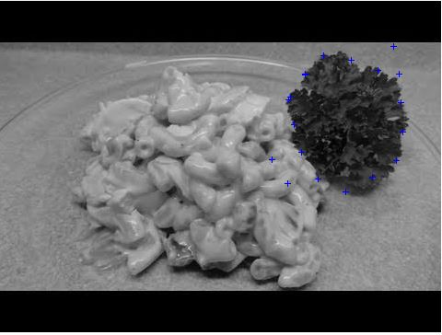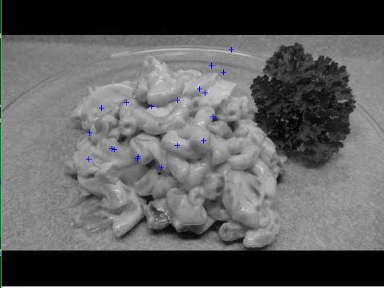

# V. Analysis of Experiment Results

Generally speaking, the experiment results are pleasing. The tool is able to segment the indicated numbers of food in each given image. Some of them has segmentation results that are very close to what human would expect, especially for the rubber band model. In manual model, the contour is able to adjust itself according to the dragged point while protecting the overall contour.

For those image that has a relatively strong color difference between items and clean outline of items would have a better segmentation. In one image, if an item is close to the edge of a plate, the contour may be locked up by the edge of the background. For example, the salmon is close to the edge of the plate, thus the result is worse than the others. If an item has a similar color with the background or another item next to it, the contour may grow across the boundary, especially in balloon model. For example, the balloon algorithm is almost useless when segmenting the lemon in the ‘fish-lemon-rice-green’. If an item does not have a smooth surface or has a relatively strong difference of color itself, in the balloon model, the contour would be locked up by the internal gradient and place where colors are different. For example, when segmenting the salmon using balloon model, it is not able to grow to the whole item.

In the manual model, the points in the contour are separated to two half using the locked point as the center. Though the points are able to adjust themselves based on the locked point and the energies, the result is still not so pleasing. Because the points are divided into two parts, they are not a circle any more. As the iteration number goes larger, the contour can be broke into two parts, which does not make sense.

There are a lot to improve the algorithms. For the balloon model, when calculating the internal energies, we can consider more about the relation between the points in the contour, instead of only calculating the distance from the center of the contour. For the manual model, we can try to implement a double direction scan when calculating the energies. From what we did before, we are only comparing each point to the next point in the contour. A double direction scan means we have another energy that detects the relation between each point and the previous point in some way.

In conclusion, this project gives me a better understanding about different kinds of active contour algorithms and win32 GUI.